The University Medical Level 1 Trauma Center in New Orleans invites you to help us decrease the number of injuries and fatalities on Louisiana roadways.

You Can Make a Difference – Child Safety Seat Class is available in your area. This is a 3-hour course for individuals who are interested in learning the proper use of child safety seats and seat belts and Louisiana child safety seat laws. Whether you are a law enforcement officer, fire and rescue personnel, EMS, healthcare providers or safety advocate, attendance will assist you to promote the proper selection, direction, harnessing and usage of child safety seats. This class is not the certification course necessary to actively participate in curbside installation and education at fitting stations and community events.

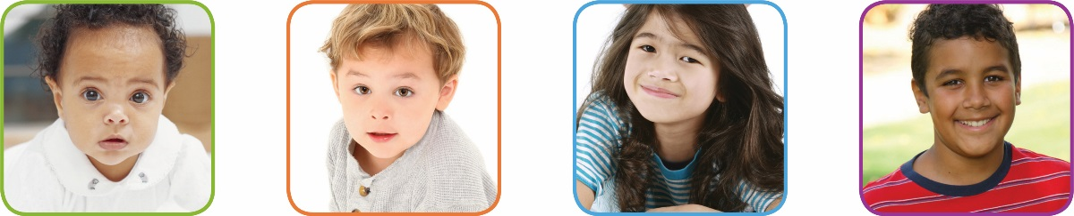

We encourage you to join our efforts and make a direct impact on traffic safety. For additional information concerning the course, please contact Bridget Gardner at (504) 702-2296, bridget.gardner@lcmchealth.org.

Registration? It’s easy – umc.org/injuryprevention

Sincerely,
Bridget Gardner RN
University Medical Center New Orleans
Program Director
Louisiana Passenger Safety Task Force

Applicant Information:

Name: ___________________________________________

Agency: ___________________________________________

Address:___________________________________________

City/Zip:____________________________________________

Phone:_(____)_____________________

Email: _____________________________________________

Location of course: ____________________
Date of course:________________

All confirmations will be sent by email.

